**________________________________________________________________**

**UNIVERSITY OF PETROLEUM & ENERGY STUDIES**

**School of Computer Science**

**Object Oriented Analysis & Design**

**Assignment 2**

**(Kirana Store(offline))**

**Submitted By: Submitted To:**

Dhruv Singhal Mr. Deepak Sharma

500075346 Asst. Professor

R177219074 SOCS

AIML B3 UPES

**Assignment Content**

Top of Form

For the selected domain (submitted to CRs), design the mentioned diagrams using any UML tool (wherever applicable) and submit the solution in a word/pdf file along with the raw file.

a) Use case Diagram

b) Class Diagram

c) Object Diagram* (UML Tool optional)

d) CRC Cards* (UML Tool optional)

e) Activity Diagram

f) Swim lane Diagram

g) Sequence Diagram

h) Collaboration Diagram

i) StateChart Diagram

j) Component and Deployment Diagram

Note*: For CRC and object diagrams you may draw the diagram on paper and add a snapshot of it in the word file.

1: USE CASE:

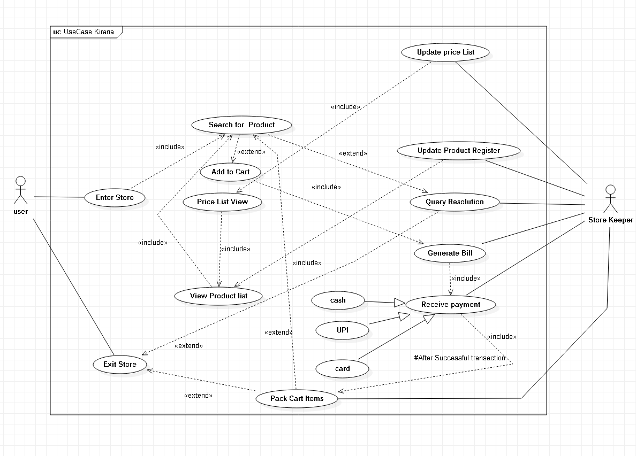

2: Class Diagram: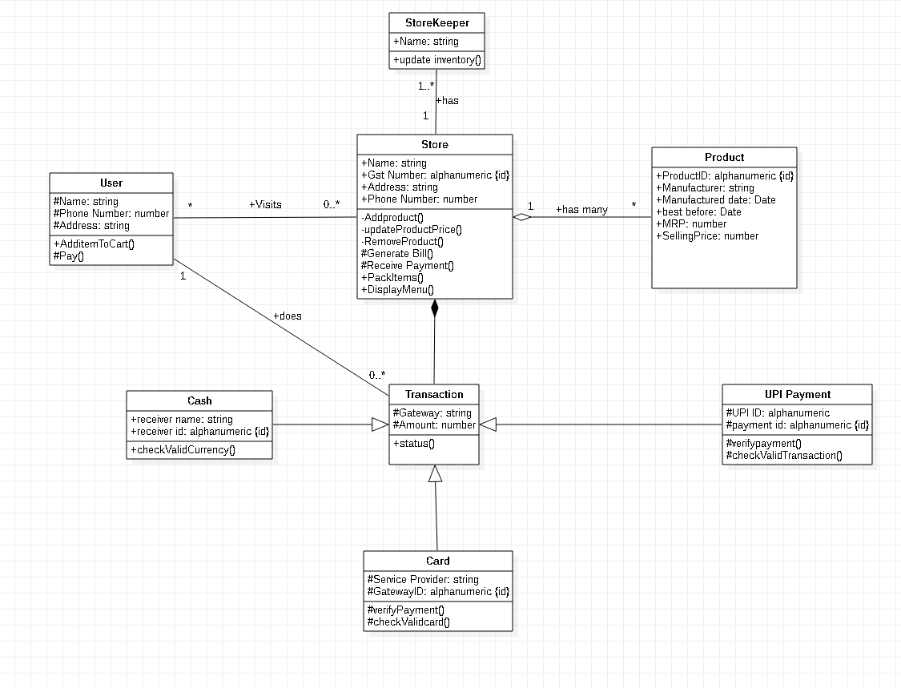

3: Object Diagram:

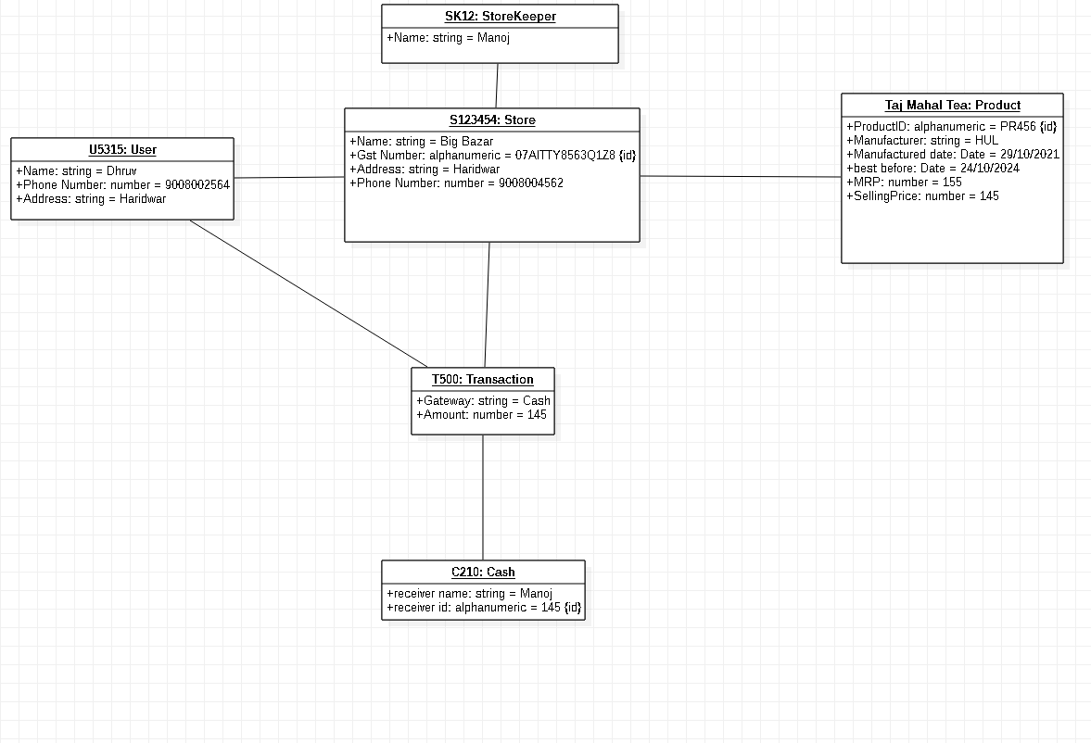

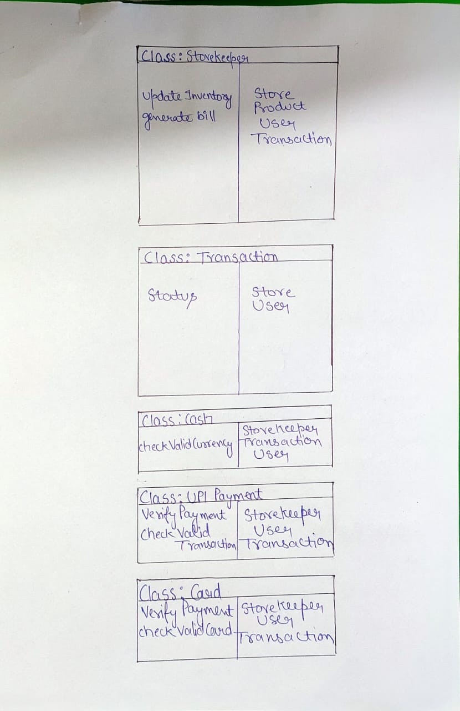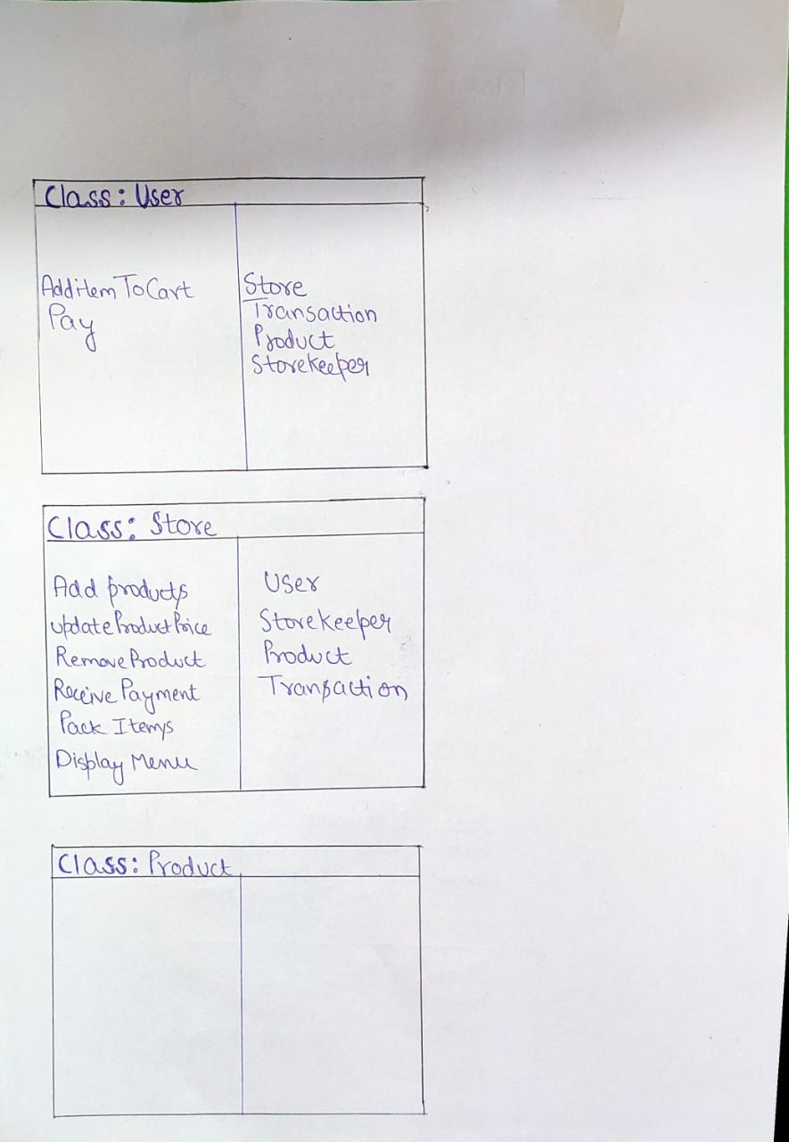4: CRC Cards:

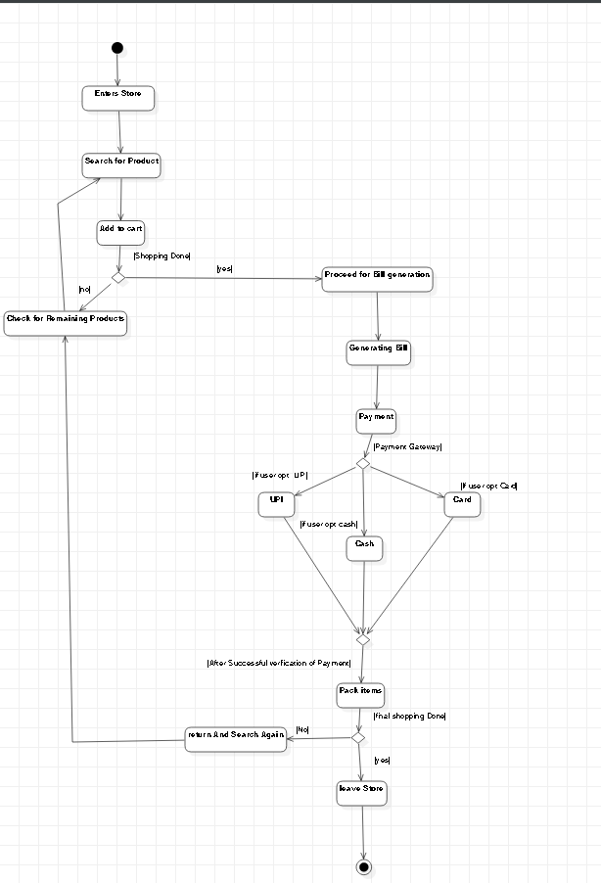5:Activity Diagram:

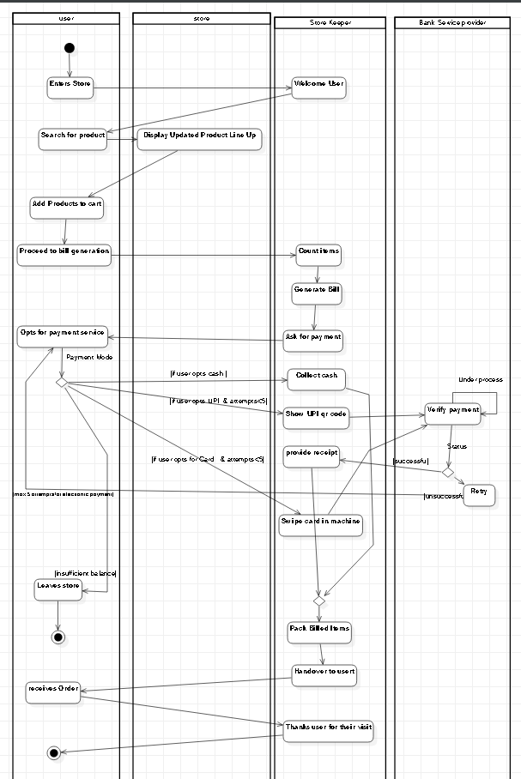6: Swimlane Diagram:

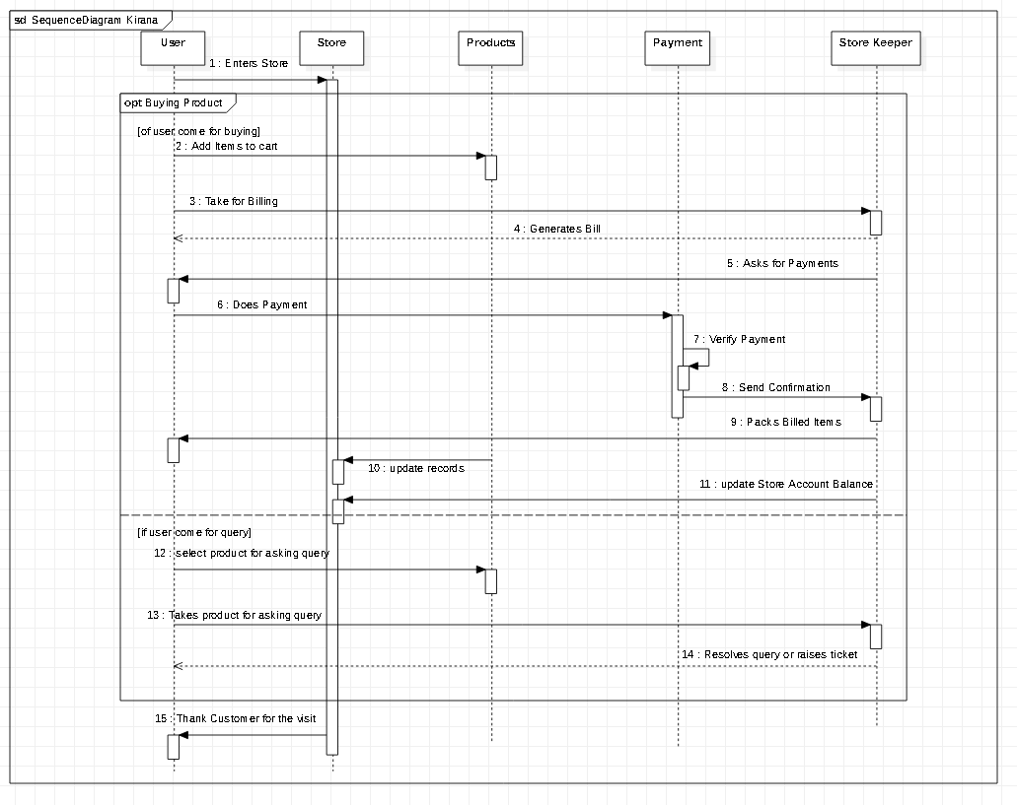7: Sequence Diagram:

8: Collaboration Diagram:

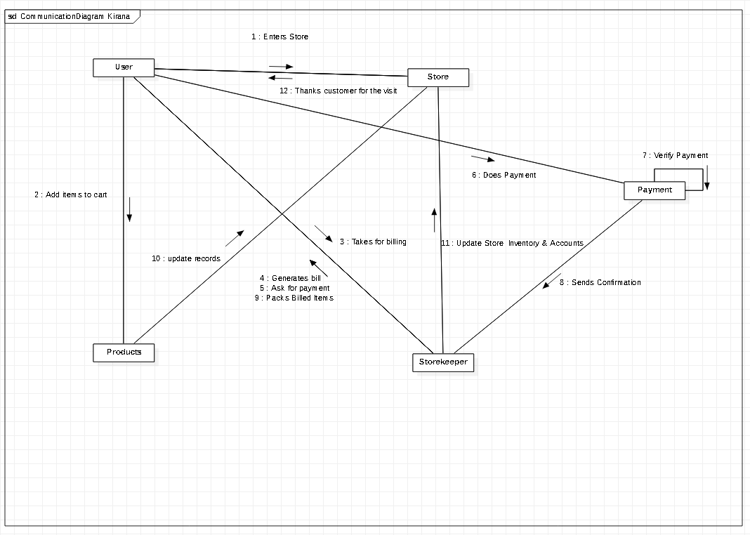

9: State Chart Diagram:

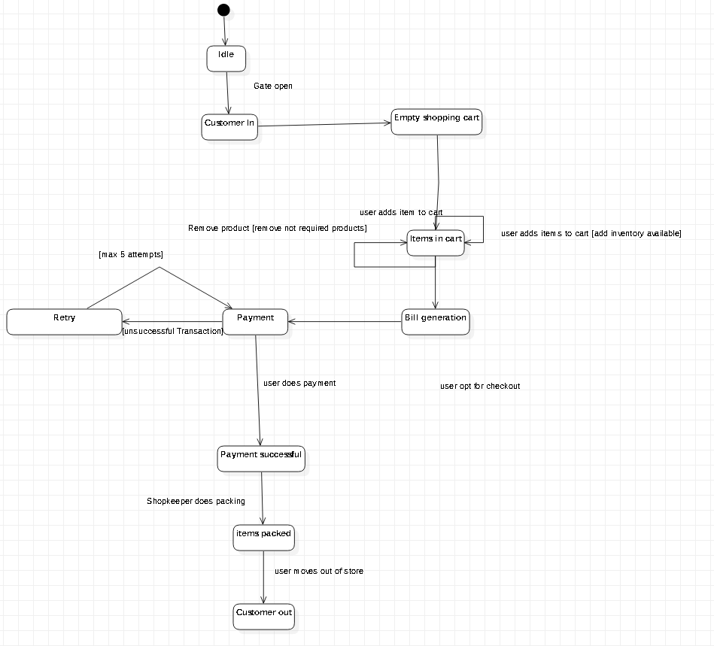

10: a: Collaboration Diagram:

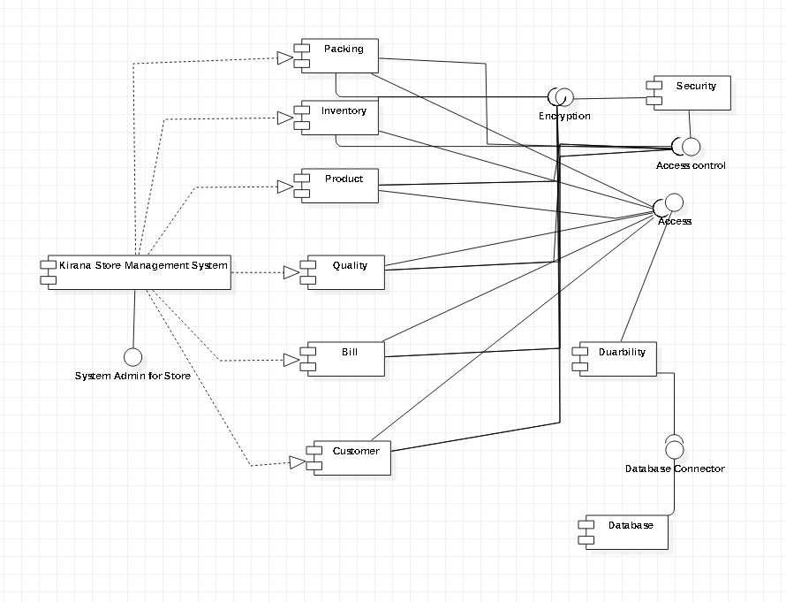

B: Deployment Diagram:

